**WEAK 1:COGNIZANT HANDS-ON PROBLEMS**

# **TOPIC:1 DESIGN PRICIPLES AND PATTERNS**

Exercise 1:Implement the singleton pattern

Output:

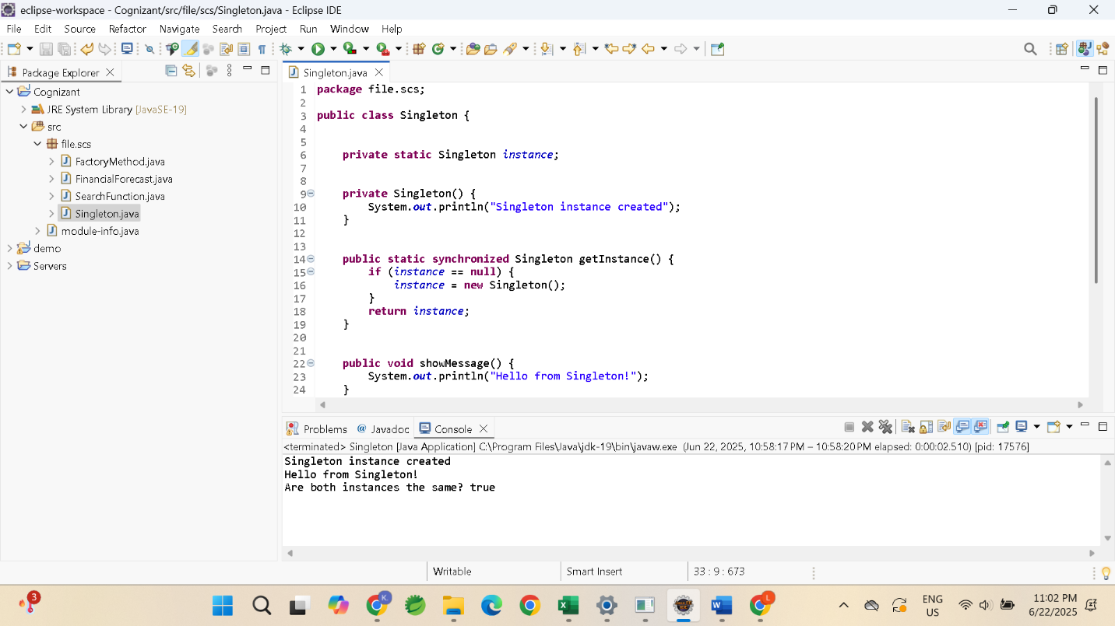

Exercise 2:Implement The Factory Method Pattern

Output:

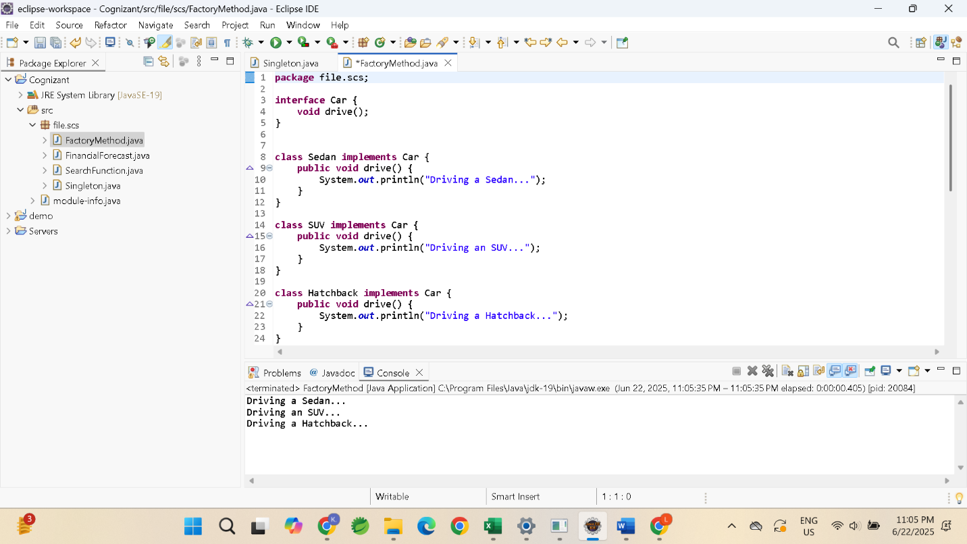

**TOPIC 2:DATA STRUCTURE AND ALGORITHMS**

Exercise 2:E-commerce platform and search function

Output:

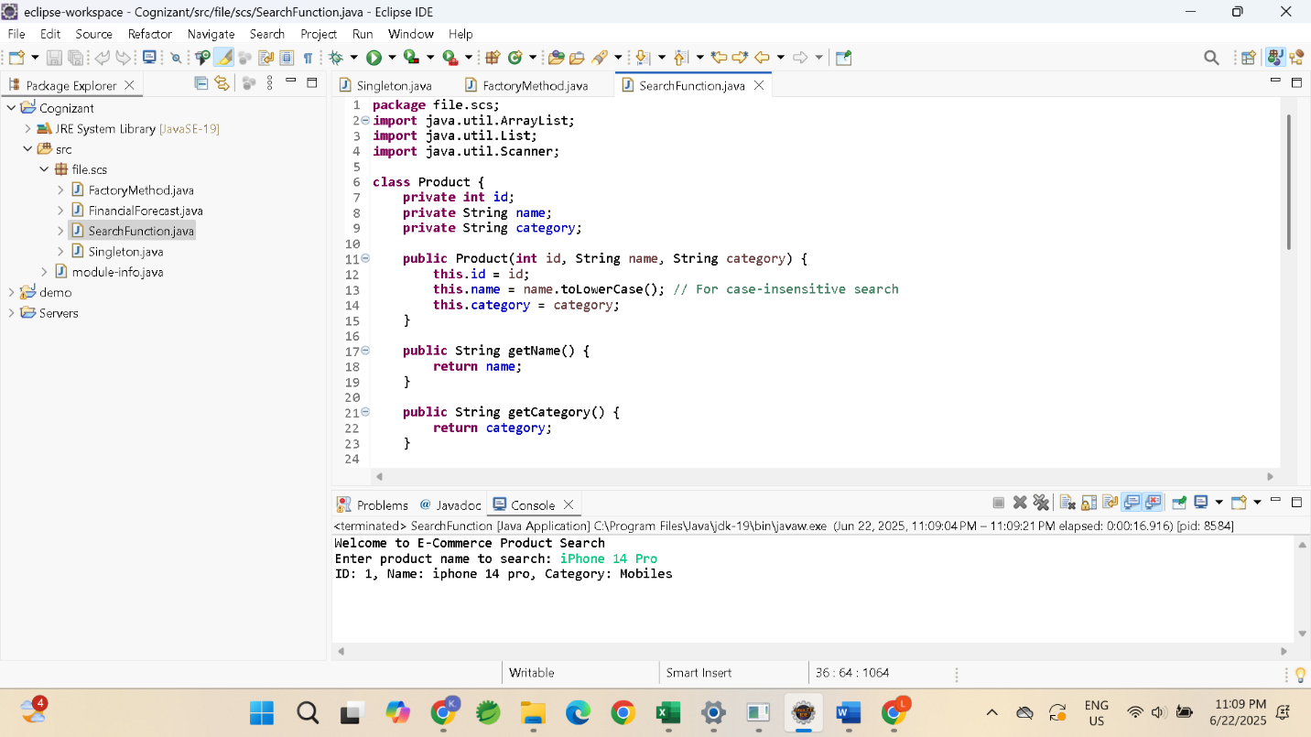

Exercise 7:Financial Forecasting

Output:

